Project Report: Micro HTTP/1.1 Server

1. Introduction
This project involves the development of a lightweight HTTP/1.1 web server built from scratch using the Berkeley Socket API in Python. The objective of the project is to understand how web servers operate at a low level, including how HTTP requests are received, parsed, and responded to without using any high-level frameworks.
The server is designed to handle basic HTTP GET requests, serve static files such as HTML and CSS, and return appropriate HTTP status codes. Through this implementation, core networking concepts such as TCP communication, request-response cycles, and protocol formatting were explored and applied.

2. System Architecture
The server follows a simple client-server architecture based on TCP communication:
- The server listens on 127.0.0.1:8080
- A client (browser or curl) sends an HTTP request
- The server accepts the connection using sockets
- The request is received and parsed manually
- The server processes the request and maps it to a file
- A properly formatted HTTP response is generated and sent back
- The connection is closed

Key Components:
- Socket Layer: Handles TCP communication using Python’s socket module
- Request Parser: Extracts HTTP method, path, and version from raw data
- File Handler: Maps URLs to files in the /public directory
- Response Builder: Constructs HTTP/1.1 compliant responses
- Error Handler: Returns appropriate error codes (400, 404, 405, 500)

3. Implementation Details

3.1 Socket Programming
The server uses the Berkeley Socket API via Python:
server_socket = socket.socket(socket.AF_INET, socket.SOCK_STREAM)
server_socket.bind((HOST, PORT))
server_socket.listen(5)
- AF_INET specifies IPv4
- SOCK_STREAM specifies TCP
- The server listens for incoming client connections

3.2 HTTP Request Handling
The server reads raw request data:
request_data = client_socket.recv(4096)
The request is then parsed manually to extract:
- HTTP Method (GET)
- Request Path (e.g., /index.html)
- HTTP Version (HTTP/1.1)
- Headers
This demonstrates a low-level understanding of HTTP protocol structure.

3.3 File Serving
Requested paths are mapped to local files inside the public/ directory:
- / → /public/index.html
- /about.html → /public/about.html
The server reads the file in binary mode:
with open(file_path, "rb") as f:
body = f.read()

3.4 HTTP Response Construction
The server manually constructs a valid HTTP/1.1 response:
HTTP/1.1 200 OK
Content-Type: text/html
Content-Length: xxx
Connection: close
<html>...</html>
Important elements:
- Status line
- Headers
- Blank line (\r\n\r\n)
- Body

3.5 Supported Features
The server supports:
- Static file serving (HTML, CSS, images)
- HTTP/1.1 request parsing
- Content-Type detection
- Multiple status codes:
  - 200 OK
  - 404 Not Found
  - 405 Method Not Allowed
  - 400 Bad Request
  - 500 Internal Server Error

4. Testing and Validation
The server was tested using both a web browser and command-line tools.

4.1 Browser Testing
Test Case | URL | Expected Result
Home Page | / | Loads index.html
Secondary Page | /about.html | Loads correctly
Invalid Page | /missing.html | Returns 404
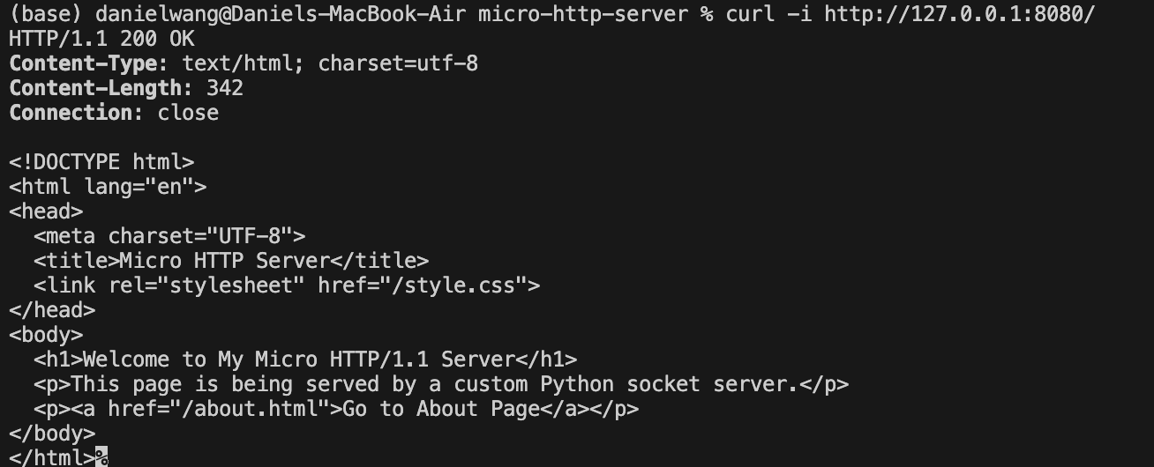
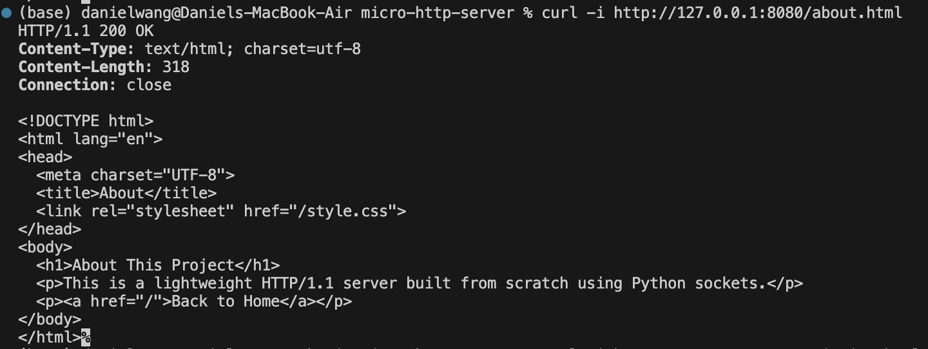
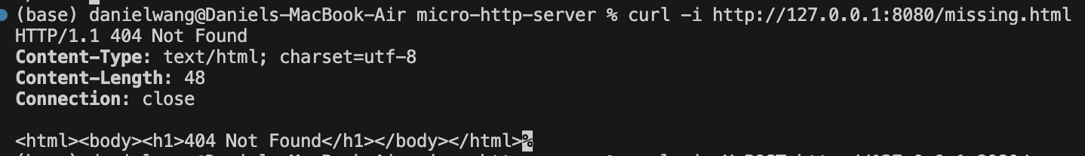
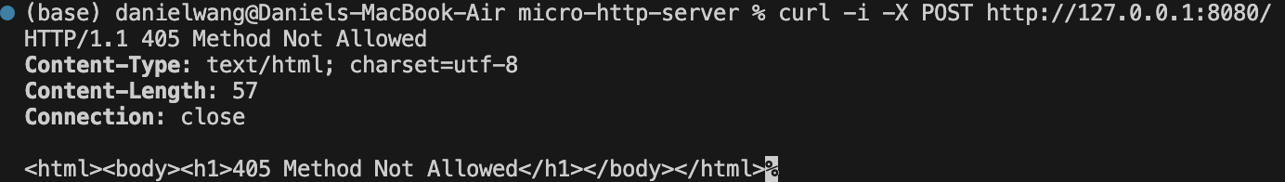
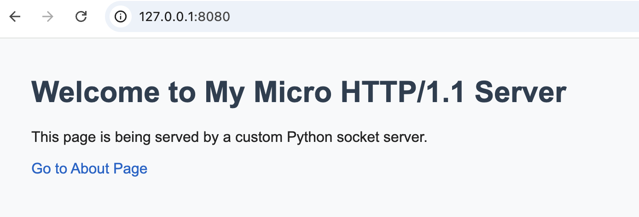
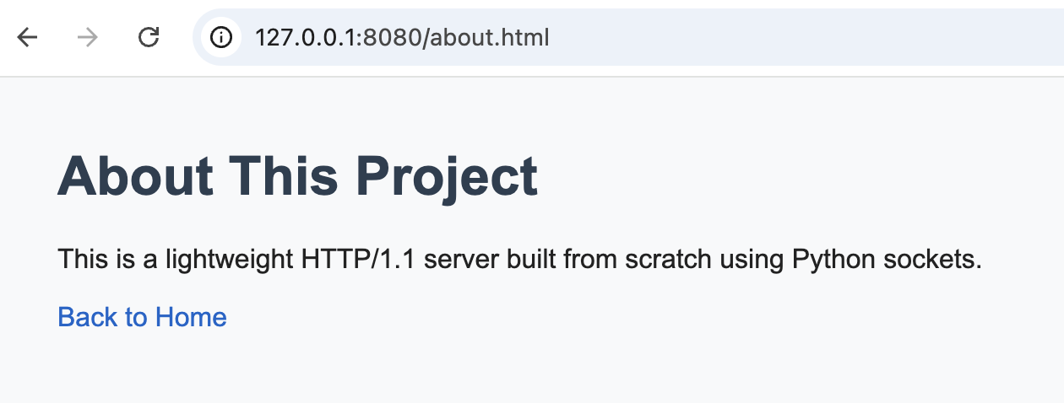
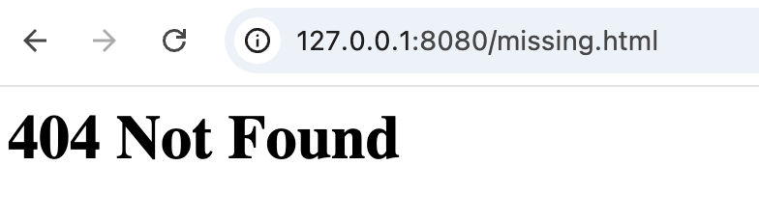

4.2 Command Line Testing
Using curl:
curl -i http://127.0.0.1:8080/
Verified:
- HTTP headers are correct
- Response format follows HTTP/1.1 standard
Testing invalid method:
curl -X POST http://127.0.0.1:8080/
Result:
- 405 Method Not Allowed

4.3 Server Logs
The server prints raw HTTP requests and processed results, confirming:
- Requests are received correctly
- Parsing logic is functioning
- Responses are being generated
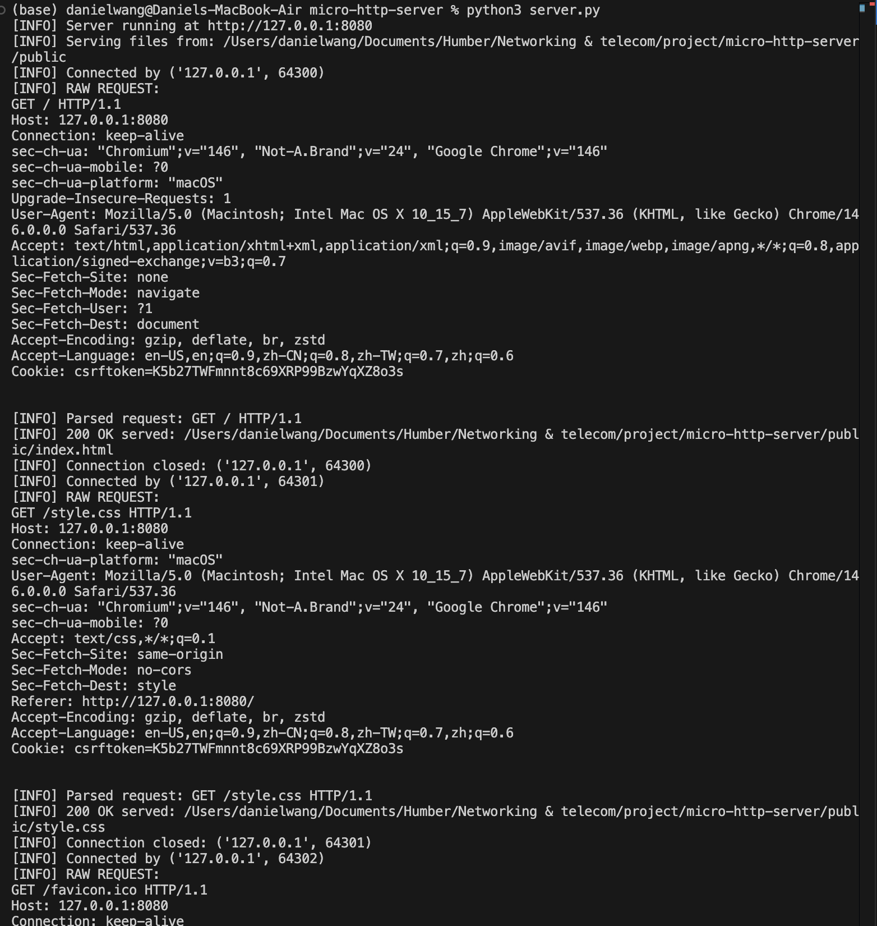

5. Challenges Faced
- Understanding raw HTTP request structure and formatting
- Correctly implementing \r\n\r\n separation between headers and body
- Handling different HTTP status codes manually
- Ensuring correct file path resolution and preventing invalid access
- Debugging issues such as ERR_EMPTY_RESPONSE due to incomplete responses

